**Pigeons**

**Overview**

*What is the desired outcome from creating the game?*

To learn game design.

*What are the goals of the game at a high level?*

Get points by shooting clay pigeons. For the gun to hit the target and make the pigeons explode. Pigeons need to be projected.

*Describe how the game will present those goals. Is there a win condition? What are we NOT intending to do, if relevant?*

There will be a scoreboard. Not trying to make a realistic weapon simulator

**Background**

**Brainstorming**

*Explore ideas and roadblocks, and their implications.*

* Launching pigeons
* Watching hardware performance problems esp. in VR
* figuring out a gun
* environment
* Textures outdoors

**Gameplay**

*Describe the gameplay at a high level. For what platform is this being developed? Which character does the player inhabit? List out the core and any special mechanics.*

Shoot a pigeon – get a point

**Requirements**

**Must have**

*Which requirements must be done for the game to be considered functionally complete (i.e. what do we consider “success”)?*

* Must have a shotgun that you can shoot with trigger.
* Must have a flying target that the player can shoot for points.
* Must have a scoreboard.
* Must be in VR.

**Nice to have**

*What requirements should be done if time permits, but aren’t required for success?*

* Reloading
* Multiple targets
* Multiple weapons
* Hands

**Concept Art and Scene Design**

**Map (if using multiple Scenes)**

*Draw a rough sketch of the game map. This should be high level, encapsulating all Scenes.*

{Insert Image}

**Scenes**

*Draw a rough sketch for each of the individual scenes, with object granularity (i.e. the scenery + discrete objects)*

{Insert Image}

**Assets** (green for complete, red for incomplete)

**3D Models + Animation**

*List any 3D models that will be required. Include details about rigging and what animations will need to be created for each object.*

* Shotgun
  + Reload animation
* Clay Pigeon
* Clay Pigeon Launcher
* Table

**2D Textures**

*Describe 2D textures to be used on the environment and 3D models, including requirements (e.g. “tileable”, “bumpmap”, etc.)*  
*Texture files should be .PNG or another lossless format. If possible, they should be sized in pixels at a power of 2 (e.g. 128x128, 512x512) to improve rendering and performance, especially in VR. Graphics cards can take advantage of faster computation when handling ^2 numbers.*

* Shotgun texture (colormap)
* Table texture (colormap)
* Ground texture (colormap)

**Sound Effects**

*List any sound effects, including the situation in which they will play, including requirements (e.g. “short”, “loopable”, “background music” etc.)*

* Shotgun shooting
* Pigeon launching
* Walking

**Architecture / Code**

*Draw a symbolic representation of the game’s object/code architecture, including Singletons and relationships between objects in the Scenes. List out classes and subclasses if necessary.*

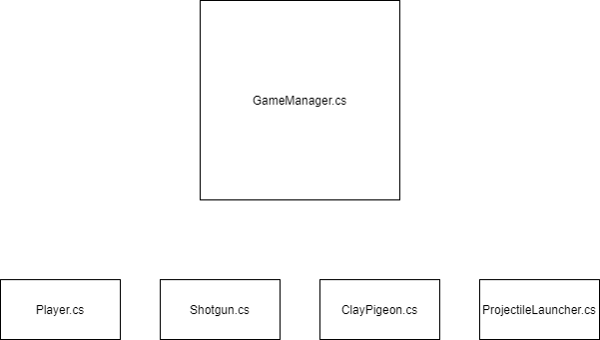

Expected Date of Completion: __ /__